**Initialization**

Tune the longitudinal and yaw acceleration noise parameters as part of the project.

The initial values for your state variables will affect your Kalman filter's performance. Both the:

* state vector **x** and the
* state covariance matrix **P**

Need to be initialized for the unscented Kalman filter to work properly.

**Initializing the State Vector x**

The state vector **x** contains *x*= [*px*​,*py*​,*v*,*ψ*,*ψ*˙​].

Once the first sensor measurement arrives, you can initialize *px*​ and *py*​.

Radar does include velocity information, the radar velocity and the CTRV velocity are not the same. Radar velocity is measured from the autonomous vehicle's perspective. If you drew a straight line from the vehicle to the bicycle, radar measures the velocity along that line.

In the CTRV model, the velocity is from the object's perspective, which in this case is the bicycle; the CTRV velocity is tangential to the circle along which the bicycle travels. Therefore, you cannot directly use the radar velocity measurement to initialize the state vector.

#### Initializing the State Covariance Matrix P

To initialize the state covariance matrix **P**, one option is to start with the identity matrix. For the CTRV model, **P** is a 5x5 matrix. The identity matrix would be:

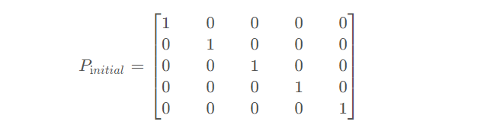

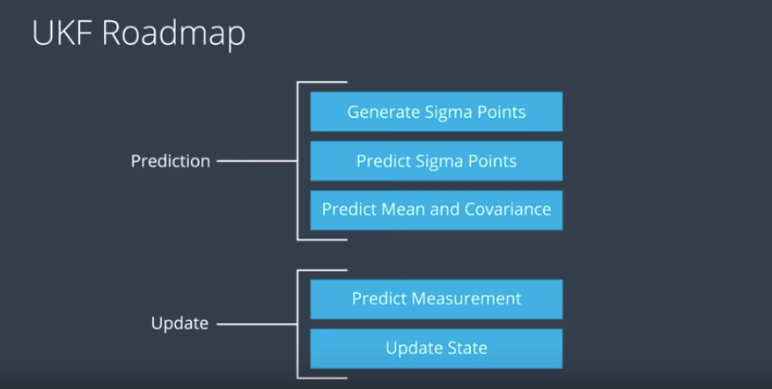

#### Generate Sigma Points

#### 

#### Augmentation

#### 

#### Sigma Points Prediction

#### 

#### Predict Mean and Covariance

#### 

#### Predict Radar Measurements

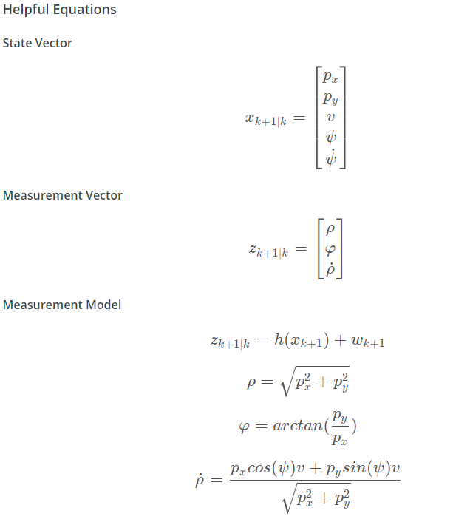

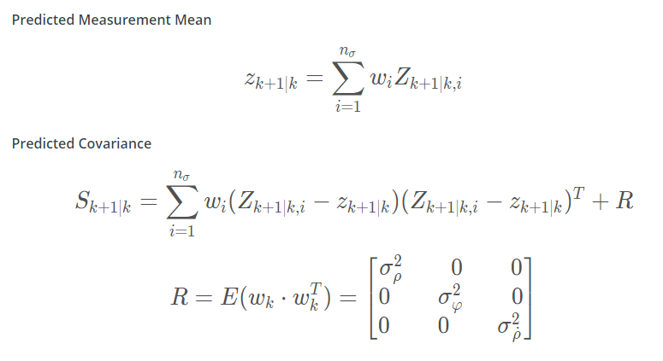

#### Parameters and Consistency

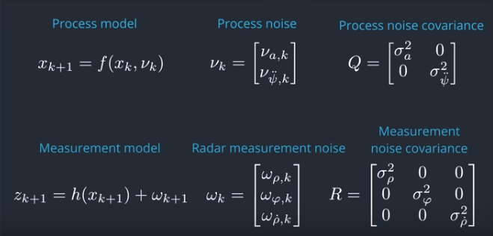

#### Consistency Check using NIS

